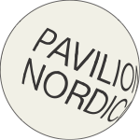
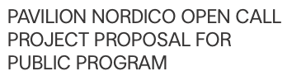

General Information

Name of individual(s):

Name of group/collective/organisation (if applicable):

Birthdate(s):

Nationality:

Address:

Email:

Telephone:

Website / Social Media:

QUESTIONS FOR PUBLIC PROGRAM PROJECT PROPOSALS

What is the title of your project and what is the main
idea behind it?
Type to enter text (1000 words)
Type to enter text (1000 words)
Briefly describe your project, its artistic and cultural content and the people and organizations involved. What will be the main outcome of your project? (1000 words)
Type to enter text (1000 words)

Give a rough budget estimate for your project proposal.
Type to enter text (1000 words)

Preferred Residency Period

Please write down your preferred time frame and project period. Projects can be between 1 day and three months. Project
proposals can take place in 2019 and 2020.
Type to enter text

Further Information

Do you wish to be considered for a travel grant? (set an X)
Yes No

Are you applying for one of the special-interest areas? (set an X)
Yes No

If so, which one?

Do you have any special needs or restrictions?

How did you learn about PAVILION NORDICO?

